# Trajectory Prediction

## High-Level

Function documentation and explanations in .h file

## Object State Machine

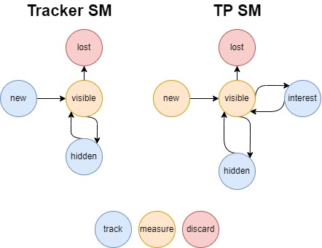

## API

## 

(You can open above file in VS so it’s more readable)

class TrajectoryPredictorHandler {

public:

    //Constructor initializes trajectory_predictor

    TrajectoryPredictorHandler(TrajectoryPredictor trajectory_predictor);

    //Parses tracker input into active_objects

    void GetTrackerData();

    //assigns active_objects from filtered (active) objects read by tracker

    //this might be implemented in GetTrackerData instead

    //or perhaps something more complicated using a state machine so, so the filtering of active objects isn't done at every time step

    void IdentifyActiveObjects();

    //Uses trajectory_predictor to generate trajectories for active objects.

    //Calls GenerateTrajectories from TrajectoryPredictor

    std::vector<ObjectTrajectory> GetActiveTrackedObjects();

private:

    TrajectoryPredictor trajectory_predictor;

    std::vector<TrackedObject> active_objects;

};

//Stores and is responsible for calculating trajectories of all relevant objects using its predict and update functions.

//May use single objects' predict and update functions for this purpose, as well as some pre/post processing ontop of these functions

//i.e. perform collision avoidance post-processing like in the interaction-aware IMM filter approach

class TrajectoryPredictor {

public:

    //calls objects' Predict()

    void Predict();

    //calls objects' Update()

    void Update(Measurement m);

    //Given a list of active objects (with new measurements inside), calculate a new set of trajectories

    //Calls UpdateActiveObjects from below to update the object_trajectories vector (add/remove/keep objects)

    void GenerateTrajectories(std::vector<TrackedObject> active_objects);

    std::vector<ObjectTrajectory> GetObjectTrajectories(){ return object_trajectories};

private:

    //Updates the object_trajectories vector so that it reflects the current set of relevant objects

    //May delete a ObjectTrajectory, or create and initialize a new one.

    //After call, every object in object_trajectories can be called with update() and predict() with new measurements

    void UpdateActiveObjects(std::vector<TrackedObject> active_objects);

    std::vector<ObjectTrajectory> object_trajectories;

};

class ObjectTrajectory {

public:

    //updates current trajectory with next-step prediction

    void Predict();

    //updates state and trajectory in accordance to newe measurement

    void Update(Measurement m);

    Trajectory GetTrajectory(){ return trajectory };

private:

    Trajectory trajectory;

};

//Tracked Object

struct {

    size_t id;

    Measurement current_measurement;

    ObjectState state;

} TrackedObject;

enum class ObjectState {

    kNew,        // low confidence

    kVisible,    // stable

    kInvisible,  // phantom

    kLost,       // to be terminated

};

//Trajectory base class

struct {

    //trajectory descriptors.

    //Might be implementation-dependant.

    //May contain waypoints, probabilities, sampling generation function, ...

} Trajectory;

//Measurement base class

struct {

    //probably just x,y.

    //Possibly more, since we can directly take tracker's speed, heading measurements. Possibly implementation-dependant

} Measurement;